Batch: A2 Roll No.: 16010122034

Experiment / Assignment / Tutorial No. 1

Grade: AA / AB / BB / BC / CC / CD /DD

Signature of the Staff In-charge with date

Experiment No. 1

TITLE: Study of Networking devices (Hub, router, Gateway, Switch etc.) and Transmission Media
___________________________________________________________________________
AIM: To study different Networking devices and transmission media used in day to day networks.
_________________________________________________________________________
Expected Outcome of Experiment:
CO 1: To introduce concepts and fundamentals of data communication and computer networks.
___________________________________________________________________________
Books/ Journals/ Websites referred:
- A. S. Tanenbaum, “Computer Networks”, Pearson Education, Fourth Edition
- B. A. Forouzan, “Data Communications and Networking”, TMH, Fourth Edition
___________________________________________________________________________
Pre Lab/ Prior Concepts: Basics of LAN and Connecting devices
___________________________________________________________________________
New Concepts to be learned: Layer wise connecting devices
___________________________________________________________________________
Stepwise-Procedure:

Study of Connecting Devices

1. Hub

A hub is a physical layer networking device which is used to connect multiple devices in a network. They are generally used to connect computers in a LAN.
A hub has many ports in it. A computer which intends to be connected to the network is plugged in to one of these ports. When a data frame arrives at a port, it is broadcast to every other port, without considering whether it is destined for a particular destination or not.
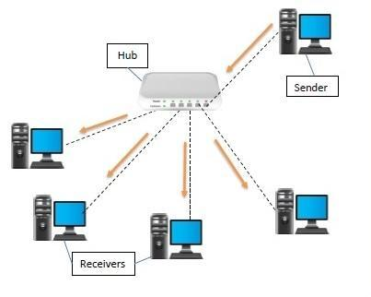

Types of Network Hubs:
Networks hubs are of the following three types:
- Active Hub: They have a power supply for regenerating, and amplifying the signals. When a port sends weak signaled data, the hub regenerates the signal and strengthens it, then sends it further to all other ports. Active hubs are expensive in costs as compared to passive hubs.
- Passive Hub: Passive hubs are simply used to connect signals from different network cables as they do not have any computerized element. They simply connect the wires of different devices in the star topology. Passive hubs do not do any processing or signal regeneration and that’s why do not require electricity the most they can do is they can copy or repeat the signal. It can’t clean the message, and it can’t amplify or strengthen the signal.
- Intelligent Hub: Intelligent hubs as the name suggests are smarter than active and passive hubs. The intelligent hub comprises a special monitoring unit named a Management Information Base (MIB). This is software that helps in analyzing and troubleshooting network problems. Intelligent hubs work similarly to active hubs but with some management features. Like it can monitor the traffic of the network and the configuration of a port.

Features of Hubs:

Hubs are the hardware device that operates in the physical layer of the OSI model.
- It supports half-duplex transmission
- It works with shared bandwidth and broadcasting.
- The hub can provide a high data transmission rate to different devices.
- It can detect collisions in the network and send the jamming signal to each port.
- Hub does not support VLAN and spanning tree protocol.
- It is unable to filter the data and hence transmit or broadcast it to each port.
- It cannot find the best route/ shortest path to send any data, which makes it an inefficient device.

Advantages of Network Hubs:
- Less expensive.
- Does not impact network performance.
- Support different network media.
- Easily connects with different media.

Disadvantages of Network Hubs:
- It cannot find the best/ shortest path of the network.
- No mechanism for traffic detection.
- No mechanism for data filtration.
- Not capable of connecting to different network topologies like token, ring, ethernet, etc.

2. Repeater

Repeaters are network devices operating at physical layer of the OSI model that amplify or regenerate an incoming signal before retransmitting it. They are incorporated in networks to expand its coverage area. They are also known as signal boosters.
When an electrical signal is transmitted via a channel, it gets attenuated depending upon the nature of the channel or the technology. This poses a limitation upon the length of the LAN or coverage area of cellular networks. This problem is alleviated by installing repeaters at certain intervals.
Repeaters amplify the attenuated signal and then retransmit it. Digital repeaters can even reconstruct signals distorted by transmission loss. So, repeaters are popularly incorporated to connect between two LANs thus forming a large single LAN.

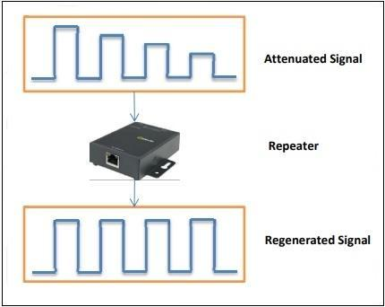

Types of Repeaters
According to the types of signals that they regenerate, repeaters can be classified into two categories
- Analog Repeaters − They can only amplify the analog signal.
- Digital Repeaters − They can reconstruct a distorted signal.
According to the types of networks that they connect, repeaters can be categorized into two types
- Wired Repeaters − They are used in wired LANs.
- Wireless Repeaters − They are used in wireless LANs and cellular networks.
According to the domain of LANs they connect, repeaters can be divided into two categories
- Local Repeaters − They connect LAN segments separated by small distance.
- Remote Repeaters − They connect LANs that are far from each other.
Advantages of Repeaters
- Repeaters are simple to install and can easily extend the length or the coverage area of networks.
- They are cost effective.
- Repeaters don’t require any processing overhead. The only time they need to be investigated is in case of degradation of performance.
- They can connect signals using different types of cables.
Disadvantages of Repeaters
- Repeaters cannot connect dissimilar networks.
- They cannot differentiate between actual signal and noise.
- They cannot reduce network traffic or congestion.
- Most networks have limitations upon the number of repeaters that can be deployed.

3. Switch
Switches are networking devices operating at layer 2 or a data link layer of the OSI model. They connect devices in a network and use packet switching to send, receive or forward data packets or data frames over the network.
A switch has many ports, to which computers are plugged in. When a data frame arrives at any port of a network switch, it examines the destination address, performs necessary checks and sends the frame to the corresponding device(s).It supports unicast, multicast as well as broadcast communications.
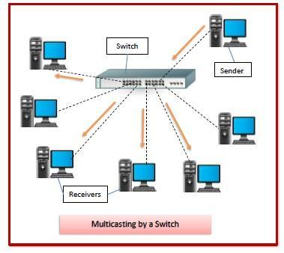
Features of Switches
- A switch operates in the layer 2, i.e. data link layer of the OSI model.
- It is an intelligent network device that can be conceived as a multiport network bridge.
- It uses MAC addresses (addresses of medium access control sublayer) to send data packets to selected destination ports.
- It uses packet switching technique to receive and forward data packets from the source to the destination device.
- It is supports unicast (one-to-one), multicast (one-to-many) and broadcast (one-to-all) communications.
- Transmission mode is full duplex, i.e. communication in the channel occurs in both the directions at the same time. Due to this, collisions do not occur.
- Switches are active devices, equipped with network software and network management capabilities.
- Switches can perform some error checking before forwarding data to the destined port.
- The number of ports is higher – 24/48.

Types of Switches
There are variety of switches that can be broadly categorised into 4 types
- Unmanaged Switch − These are inexpensive switches commonly used in home networks and small businesses. They can be set up by simply plugging in to the network, after which they instantly start operating. When more devices needs to be added, more switches are simply added by this plug and play method. They are referred to as u managed since they do not require to be configured or monitored.
- Managed Switch − These are costly switches that are used in organisations with large and complex networks, since they can be customized to augment the functionalities of a standard switch. The augmented features may be QoS (Quality of Service) like higher security levels, better precision control and complete network management. Despite their cost, they are preferred in growing organizations due to their scalability and flexibility. Simple Network Management Protocol (SNMP) is used for configuring managed switches.
- LAN Switch − Local Area Network (LAN) switches connects devices in the internal LAN of an organization. They are also referred as Ethernet switches or data switches. These switches are particularly helpful in reducing network congestion or bottlenecks. They allocate bandwidth in a manner so that there is no overlapping of data packets in a network.
- PoE Switch − Power over Ethernet (PoE) switches are used in PoE Gogabit Ethernets. PoE technology combine data and power transmission over the same cable so that devices connected to it can receive both electricity as well as data over the same line. PoE switches offer greater flexibility and simplifies the cabling connections

4. Bridge
Bridges are used to connect two subnetworks that use interchangeable protocols. It combines two LANs to form an extended LAN. The main difference between the bridge and repeater is that the bridge has a penetrating efficiency.
A bridge accepts all the packets and amplifies all of them to the other side. The bridges are intelligent devices that allow the passing of only selective packets from them. A bridge only passes those packets addressed from a node in one network to another node in the other network.
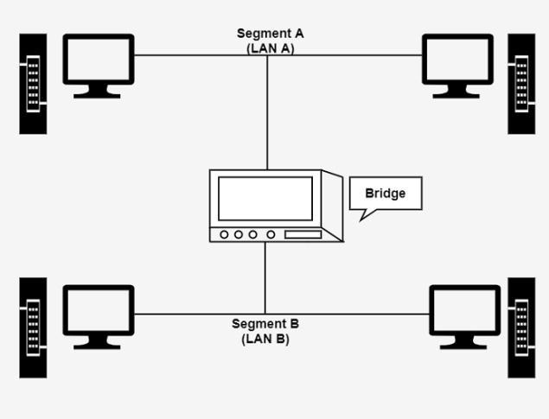
A bridge performs in the following aspect −
- A bridge receives all the packets or frame from both LAN (segment) A and B.
- A bridge builds a table of addresses from which it can identify that the packets are sent from which LAN (or segment) to which LAN.
- The bridge reads the send and discards all packets from LAN A sent to a computer on LAN A and that packets from LAN A send to a computer on LAN B are retransmitted to LAN B.
- The packets from LAN B are considered in the same method.

Types of Bridges
There are generally two types of bridges which are as follows −

Transparent Bridges
It is also called learning bridges. Bridge construct its table of terminal addresses on its own as it implements connecting two LANs. It facilitates the source location to create its table. It is self-updating. It is a plug and plays bridge.

Source Routing Bridge
This sending terminal means the bridges that the frames should stay. This type of bridge is used to prevent looping problem.

Uses of Bridges
The main uses of bridges are −
- Bridges are used to divide large busy networks into multiple smaller and interconnected networks to improve performance.
- Bridges also can increase the physical size of a network.
- Bridges are also used to connect a LAN segment through a synchronous modem relation to another LAN segment at a remote area.

5. Router
Routers are networking devices operating at layer 3 or a network layer of the OSI model. They are responsible for receiving, analysing, and forwarding data packets among the connected computer networks. When a data packet arrives, the router inspects the destination address, consults its routing tables to decide the optimal route and then transfers the packet along this route.
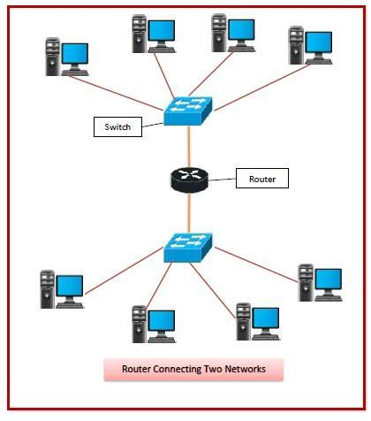
Features of Routers
- A router is a layer 3 or network layer device.
- It connects different networks together and sends data packets from one network to another.
- A router can be used both in LANs (Local Area Networks) and WANs (Wide Area Networks).
- It transfers data in the form of IP packets. In order to transmit data, it uses IP address mentioned in the destination field of the IP packet.
- Routers have a routing table in it that is refreshed periodically according to the changes in the network. In order to transmit data packets, it consults the table and uses a routing protocol.
- In order to prepare or refresh the routing table, routers share information among each other.
- Routers provide protection against broadcast storms.
- Routers are more expensive than other networking devices like hubs,bridges and switches.

Types of Routers
A variety of routers are available depending upon their usages. The main types of routers are
- Wireless Router − They provide WiFi connection WiFi devices like laptops, smartphones etc. They can also provide standard Ethernet routing. For indoor connections, the range is 150 feet while its 300 feet for outdoor connections.
- Broadband Routers − They are used to connect to the Internet through telephone and to use voice over Internet Protocol (VoIP) technology for providing high-speed Internet access. They are configured and provided by the Internet Service Provider (ISP).
- Core Routers − They can route data packets within a given network, but cannot route the packets between the networks. They helps to link all devices within a network thus forming the backbone of network. It is used by ISP and communication interfaces.
- Edge Routers − They are low-capacity routers placed at the periphery of the networks. They connect the internal network to the external networks, and are suitable for transferring data packets across networks. They use Border Gateway Protocol (BGP) for connectivity. There are two types of edge routers, subscriber edge routers and label edge routers.
- Brouters − Brouters are specialised routers that can provide the functionalities of bridges as well. Like a bridge, brouters help to transfer data between networks. And like a router, they route the data within the devices of a network.

6. Gateway
A device that can bridge multiple network structures is known as a gateway. Therefore gateways can connect two dissimilar LANs. The major difference between gateways and routers is that routers work at the OSI model’s network layer. In contrast, gateways work from the lowest to the topmost layer, i.e., the application layer to the OSI model’s network layer.
Gateways and routers are used correspondingly. It can transform data packets from one protocol architecture to another before forwarding them to connect two multiple networks. Therefore it includes protocol conversion services at the application layer. A gateway is a connecting device that can relate to several networks. They can be implemented at the application layer of the OSI model. They handle messages, locations, and protocol conversion to produce a packet to its terminal among two connections.
The main disadvantage of the gateway is that gateways are moderate because they need to implement intensive conversions.
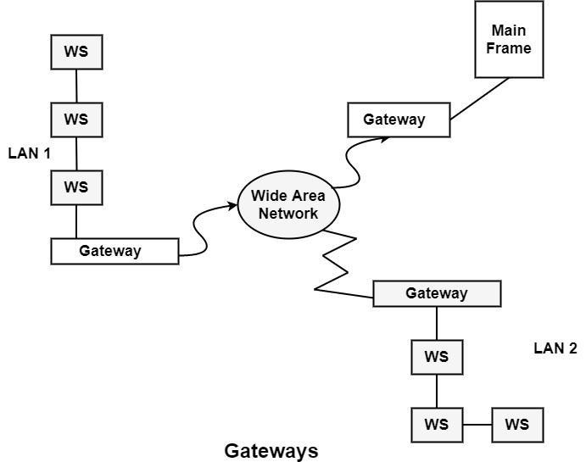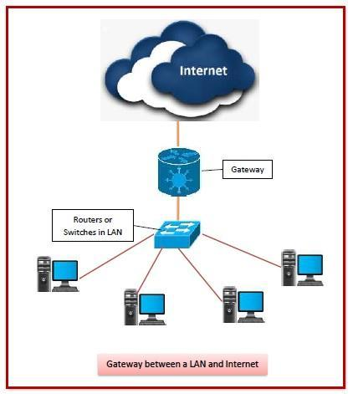

Features of Gateways
- Gateway is located at the boundary of a network and manages all data that inflows or outflows from that network.
- It forms a passage between two different networks operating with different transmission protocols.
- A gateway operates as a protocol converter, providing compatibility between the different protocols used in the two different networks.
- The feature that differentiates a gateway from other network devices is that it can operate at any layer of the OSI model.
- It also stores information about the routing paths of the communicating networks.
- When used in enterprise scenario, a gateway node may be supplemented as proxy server or firewall.
- A gateway is generally implemented as a node with multiple NICs (network interface cards) connected to different networks. However, it can also be configured using software.
- It uses packet switching technique to transmit data across the networks.

Study of Transmission Media
The below information is given for reference purpose only; you need to replace this with the information you have searched
1. Twisted pair cable
A twisted pair cable is made of two plastic insulated copper wires twisted together to form a single media. Out of these two wires, only one carries actual signal and another is used for ground reference. The twists between wires are helpful in reducing noise (electro-magnetic interference) and crosstalk.
There are two types of twisted pair cables:
- Shielded Twisted Pair (STP) Cable
- Unshielded Twisted Pair (UTP) Cable
STP cables comes with twisted wire pair covered in metal foil. This makes it more indifferent to noise and crosstalk.
UTP has seven categories, each suitable for specific use. In computer networks, Cat-5, Cat-5e, and Cat-6 cables are mostly used. UTP cables are connected by RJ45 connectors.
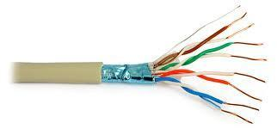
Applications of Twisted pair cables :
- Twisted Pair cables are used in telephone lines to provide data and voice channels.
- The DSL lines make use of these cables.
- Local Area Networks (LAN) also make use of twisted pair cables.
- They can be used for both analog and digital transmission.
- RJ-45 is a very common application of twisted pair cables.

2. Coaxial cable
Coaxial cable has two wires of copper. The core wire lies in the center and it is made of solid conductor.The core is enclosed in an insulating sheath.The second wire is wrapped around over the sheath and that too in turn encased by insulator sheath.This all is covered by plastic cover.
Because of its structure,the coax cable is capable of carrying high frequency signals than that of twisted pair cable.The wrapped structure provides it a good shield against noise and cross talk. Coaxial cables provide high bandwidth rates of up to 450 mbps.
There are three categories of coax cables namely, RG-59 (Cable TV), RG-58 (Thin Ethernet), and RG-11 (Thick Ethernet). RG stands for Radio Government.
Cables are connected using BNC connector and BNC-T. BNC terminator is used to terminate the wire at the far ends.
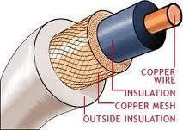
3. Optical Fiber
Fiber Optic works on the properties of light. When light ray hits at critical angle it tends to refracts at 90 degree. This property has been used in fiber optic. The core of fiber optic cable is made of high quality glass or plastic. From one end of it light is emitted, it travels through it and at the other end light detector detects light stream and converts it to electric data.
Fiber Optic provides the highest mode of speed. It comes in two modes, one is single mode fiber and second is multimode fiber. Single mode fiber can carry a single ray of light whereas multimode is capable of carrying multiple beams of light.

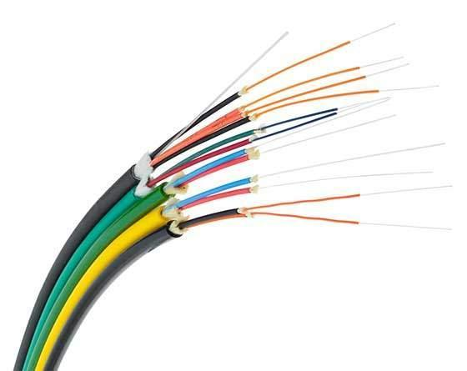
Summary:
The features of the connecting devices and transmission media can be explained in brief as follows:
- Facilitate data transmission and communication between devices
- Enable efficient and secure network connectivity
- Enhance network performance and optimize traffic flow
- Provide network security by enforcing access control and threat prevention
- Simplify network management and configuration
- Extend network coverage and overcome signal limitations
Conclusion:
A network device is a piece of hardware or software integral to communication between a computer and an internet network. Both physical and digital network devices play two roles. The first is establishing a network connection, as a router or a modem does. The second one is maintaining, protecting and enhancing that connection, as with a hub, repeater, switch or gateway.
Network devices establish and maintain a secure and effective internet connection. These devices link computers, phones, printers and other internet-compatible devices with various networks. They also block potentially dangerous data or users from entering secure networks. They also improve efficiency, range and security.

Post Lab Questions

- Compare Hub, switch, bridge, and gateway and specify the use in different cases.

Key | Hub | Switch | Bridge | Gateway
Objective | A hub transmits the signal to a port, which will respond to where the signal was received. | A switch allows you to set up and terminate connections as needed. | A bridge is a network device that connects two distinct LANs that utilize the same protocol. | A gateway is a passage to connect two networks that may work upon different networking models.
Layer | Physical Layer | Data Link Layer / Network Layer | Data Link Layer | All layers
Ports | Maximum 4 ports. | 24 to 28 ports | Only 2 ports | -
Packet Filtering | No packet filtering | Provide packet filtering | Provide packet filtering | No packet filtering
Transmission Mode | Half duplex transmission mode | Full duplex transmission mode | Half duplex transmission mode | -

- Which of the following device is used to connect two systems, especially if the systems use different protocols?
A. Hub
B. Bridge
C. Gateway
D. Repeater
E. None of the above

- Frames from one LAN can be transmitted to another LAN via the device
A. Router
B. Bridge
C. Repeater
D. Modem

